Brain Scanners and Free Will

[This is an email I sent to friends on April 12, 2008, together with an article about some recent findings in brain research which are relevant to the topic of “free will”. –S.H.]

Hi science fans,
(This email is sort of a three-minute course on the philosophy of mind!)
Included below is an article of considerable interest. Read the article first, then come back to these comments:
First, Benjamin Libet’s finding to this same general effect was discussed in Daniel Dennet’s book Consciousness Explained, that our book club read several years ago.
Second, the very long 7-second time delay here is somewhat suspect. (Libet found only a delay of a fraction of a second.) Moreover, it is easy to show that sometimes, at least, the delay cannot possibly be that long. For example, suppose the subject decides to push the button with their left hand if they hear any sound while they silently count to 3 (1000-and-1, 1000-and-2, 1000-and-3), but to otherwise immediately push the right hand button. Then the decision will be both made and carried out within 4 or 5 seconds at most.
Nevertheless, under the precise experimental conditions described, the 7-second delay finding may often be correct.
But third, and contrary to the article, the experiment actually tells us nothing about whether human beings have “free will”.
We do, however, have free will, which means that we can decide what to do (in a case like this). But what that really means is that our conscious decision process is part of a larger physical development process in our brain-body system much of which is UNconscious. That is, the conscious recognition of our own decision comes after the actual decision has been made—even though we did in fact make that decision! Think about it! You'll see this has to be correct. No matter what we do, even if it is to make a conscious decision about something, not everything the brain does in making this conscious decision can itself be conscious.
Fourth, Mark Hallett is said to put it this way: Our unease in this situation originates in a misconception of self as separate from the brain. That’s close, but actually it would be better to say that our unease originates in thinking of our conscious self as being independent of our whole mind-brain-body physical system.
Hallett himself seems to be arguing for the “identity theory” (mind = brain). That’s not quite right; the mind s a set of functional views of the brain. So yes, the mind does have a physical basis in a developing physical system (the brain-body system), but the mind and mentalistic terms are special functional ways of looking at aspects of the functioning physical system.
And finally, fifth, free will in no way is actually opposed to determinism. Our mind-brain-body system is in fact deterministic, but part of that involves deterministic chains of cause and effect that include what we correctly view as conscious choices. But of course there are ultimately always reasons (causes) for our choices, and we wouldn’t want it any other way!
Scott
From: http://www.wired.com/print/science/discoveries/news/2008/04/mind_decision
Science : Discoveries
Brain Scanners Can See Your Decisions
Before You Make Them
By Brandon Keim 04.13.08 | 1:00 PM

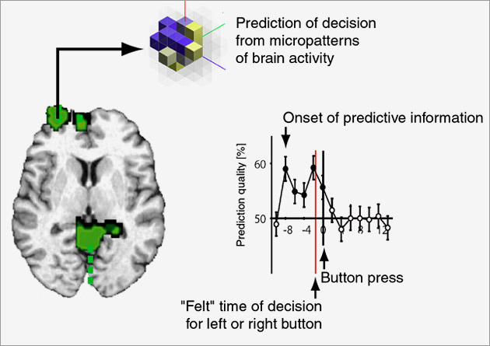

This schematic shows the brain regions (green) from which the outcome of a participant's decision can be predicted before it is made.
Courtesy John-Dylan Haynes.
You may think you decided to read this story -- but in fact, your brain made the decision long before you knew about it.
In a study published Sunday in Nature Neuroscience, researchers using brain scanners could predict people's decisions seven seconds before the test subjects were even aware of making them.
The decision studied -- whether to hit a button with one's left or right hand -- may not be representative of complicated choices that are more integrally tied to our sense of self-direction. Regardless, the findings raise profound questions about the nature of self and autonomy: How free is our will? Is conscious choice just an illusion?
"Your decisions are strongly prepared by brain activity. By the time consciousness kicks in, most of the work has already been done," said study co-author John-Dylan Haynes, a Max Planck Institute neuroscientist.
Haynes updated a classic experiment by the late Benjamin Libet, who showed that a brain region involved in coordinating motor activity fired a fraction of a second before test subjects chose to push a button. Later studies supported Libet's theory that subconscious activity preceded and determined conscious choice -- but none found such a vast gap between a decision and the experience of making it as Haynes' study has.
In the seven seconds before Haynes' test subjects chose to push a button, activity shifted in their frontopolar cortex, a brain region associated with high-level planning. Soon afterwards, activity moved to the parietal cortex, a region of sensory integration. Haynes' team monitored these shifting neural patterns using a functional MRI machine.
Taken together, the patterns consistently predicted whether test subjects eventually pushed a button with their left or right hand -- a choice that, to them, felt like the outcome of conscious deliberation. For those accustomed to thinking of themselves as having free will, the implications are far more unsettling than learning about the physiological basis of other brain functions.
Caveats remain, holding open the door for free will. For instance, the experiment may not reflect the mental dynamics of other, more complicated decisions.
"Real-life decisions -- am I going to buy this house or that one, take this job or that -- aren't decisions that we can implement very well in our brain scanners," said Haynes.
Also, the predictions were not completely accurate. Maybe free will enters at the last moment, allowing a person to override an unpalatable subconscious decision.
"We can't rule out that there's a free will that kicks in at this late point," said Haynes, who intends to study this phenomenon next. "But I don't think it's plausible."
That implausibility doesn't disturb Haynes.
"It's not like you're a machine. Your brain activity is the physiological substance in which your personality and wishes and desires operate," he said.
The unease people feel at the potential unreality of free will, said National Institutes of Health neuroscientist Mark Hallett, originates in a misconception of self as separate from the brain.
"That's the same notion as the mind being separate from the body -- and I don't think anyone really believes that," said Hallett. "A different way of thinking about it is that your consciousness is only aware of some of the things your brain is doing."
Hallett doubts that free will exists as a separate, independent force.
"If it is, we haven't put our finger on it," he said. "But we're happy to keep looking."
[End]

